Motor driver:

1-l298n :

Supports high currents up to (2 A)

2-l293d :

Supports currents up to 600 Ma.

L298n

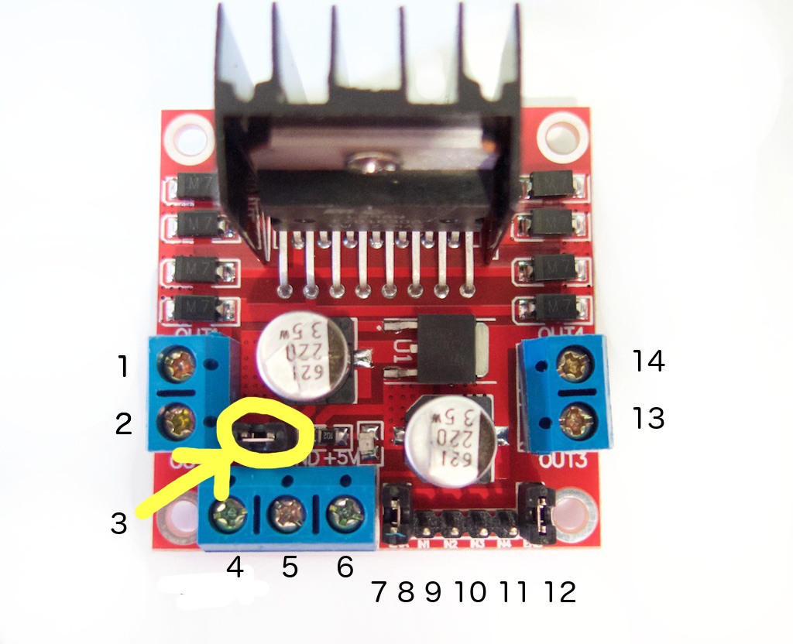

Pins 1,2,14,13 :motors

Pin 4 :dc motor supply

Pin5 :gnd of the source and from the Arduino

Pin 6 :5 v output for the arduino

Pin 7,12: enable pins for the motors to control the

Speed of motors if needed.

They are also connected to enable pins on the Arduino.

Pins 8-11:input pins from the Arduino.

Sensor

Hc-sr04

Trig and echo pins are connected to any digital pins on the Arduino.

Servo

It needs a 5 v and gnd pin from Arduino

And any other digital pin.